**Project Report**

On

**AutoWorth AI**

Submitted during 5th semester in partial fulfilment of the requirements for the award of degree of

**Bachelor of Technology**

in

**Electronics and Computer Engineering**

by

**Sakshi Mittal (22001015055)**

**Nishtha (22001015042)**

**(2022-2026)**

Under supervision of

**Mrs. Abhilasha**



**Department of Electronics Engineering**

**J.C. Bose University of Science & Technology, YMCA**

**Faridabad – 121006**

**Dec 2024**

**TABLE OF CONTENT**

**Candidate’s Declaration**

**Certificate**

**Acknowledgement**

**Chapter 1: Introduction**

* Brief Of Project
* Technologies Used

**Chapter 2: Project Timeline**

2.1 Home Page

2.2 Output Summary

**Chapter 3: Implementation**

3.1 Snapshots of Home Page

3.2 Filling Car Details

3.3 Prediction

**Chapter 4: Application and Future Scope**

4.1 Applications

4.2 Future Scope

**References**

**CANDIDATE’S DECLARATION**

I hereby certify that the work being presented in this Project titled **“_AutoWorth AI**_” in partial fulfilment of the requirements for the degree of Bachelor of Technology in __Electronics and Computer__and being submitted to “J.C. Bose University of Science and Technology, YMCA, Faridabad”, is an authentic record of my own work carried out under the supervision of Dr/Ms/Mr /Mrs **Abhilasha**.

The work contained in this project has not been submitted to any other University or Institute for the award of any degree or diploma by me.

**Sakshi Mittal**

**Nishtha**

**CERTIFICATE**

It is hereby certified that the following project is a record of a bonafide work carried out by

Sakshi Mittal (22001015055) and Nishtha Kathpal (22001015042) of B.Tech. Electronics and

Computer Engineering 3rd Year, (5th Semester) student under the Project Workshop-II – J.C.

Bose University of Science and Technology, YMCA, Faridabad under my supervision as a

mentor Mrs. Abhilasha during the semester Dec 2024.

In my opinion, the project has reached the standards of fulfilling the requirements of

the regulations to the degree.

**Mrs. Abhilasha**

Professor

**ACKNOWLEDGEMENT**

I have taken efforts in this project. However, it would not have been possible

without the kind support and help of many individuals.

I would like to extend my sincere thanks to all them. I am highly indebted to Mrs.

Abhilasha for their guidance and constant supervision as well as for providing necessary

Information regarding the project & also for their support in completing the project.

I would like to express my gratitude towards my parents & members of J.C. Bose

University of Science and Technology for their kind cooperation and encouragement

which helped in the completion of this project.

I would like to express my special gratitude and thanks to YouTube tutors as well

for their guidance.

**Sakshi Mittal**

**Nishtha**

**Chapter 1**

**Introduction**

**1.1 Brief of the Project**

The 'Car Price Predictor' project is designed to address the challenges faced by car buyers and sellers in determining fair market prices. With the vast number of variables such as car make, model, year, mileage, condition, and location, manually assessing the value of a car can be time-consuming and often inaccurate. This project employs machine learning algorithms to analyze a large dataset of car prices, accounting for various factors that influence car valuation.

The model uses regression techniques, such as linear regression or more advanced methods like decision trees, random forests, or gradient boosting, to predict the price of a car based on input features. By learning from historical data, the model can predict a reasonable market value, taking into account not just the basic details but also trends in the market, regional differences, and depreciation rates.

The web-based interface provides an easy-to-use platform for users to input the details of the car they are interested in. After submitting the information, the system returns an estimated market price, along with confidence intervals, so users can assess whether they are paying or receiving a fair price. This solution is aimed at both individual buyers and sellers, as well as dealers who need an efficient pricing tool.

By making this machine learning model accessible through a simple and intuitive web interface, the project ensures that anyone, regardless of their technical background, can benefit from accurate car price predictions. The integration of machine learning with a user-friendly interface contributes to transparency in the buying and selling process, empowering users to make informed decisions. Moreover, as the model evolves, it can incorporate more sophisticated features, such as real-time data integration, to keep up with market changes and offer even more precise estimations.

This project not only showcases the power of machine learning in real-world applications but also provides a valuable service to the automotive industry, making car pricing more transparent and accessible to a wider audience.

**1.2 Technologies Used**

**Machine Learning Algorithms:**

* Purpose: The core of the project is predicting the market price of cars based on various features such as car age, mileage, brand, model, fuel type, etc. Machine learning algorithms help learn patterns from historical car pricing data and predict prices for new or used cars. These predictions offer insights into the expected market value based on a combination of different car attributes.
* Models Used:
* Linear Regression: A basic but powerful algorithm used to model the relationship between the features (such as mileage, brand, etc.) and the car price. Linear regression helps predict the car price by fitting a line through the data points in a way that minimizes the prediction error.

**Data Preprocessing:**

* Purpose: Data preprocessing is crucial in transforming raw data into a suitable format for machine learning models. Proper preprocessing ensures that the model can learn accurately and efficiently from the data, which directly impacts the prediction quality.
* Techniques:
* Handling Missing Data: Missing values in the dataset are addressed using imputation methods like filling in with the mean, median, or predictive models to estimate the missing values. This ensures the model is trained on complete data.
* Encoding Categorical Features: Categorical features, such as car brand or model, are converted into numerical values using techniques like one-hot encoding or label encoding. This allows the model to process categorical data.
* Normalization/Scaling: Features with different units (like mileage and price) are scaled to a common range. This step ensures that the machine learning model treats these features equally and helps in better performance during training.

**Web Development:**

* **Frontend:**
* HTML/CSS: These technologies are used to create the structure and style of the web application. HTML is used for the basic structure of the page (forms, buttons), and CSS is used for the design aspects such as colors, fonts, and layout to make the application aesthetically pleasing and user-friendly.
* JavaScript: Adds interactivity to the web interface, enabling features like form submission, displaying predictions in real-time, and validating user inputs before submission. It helps in creating a smooth and dynamic user experience.
* **Backend:**
* Flask (Python): Flask is a lightweight Python web framework used for the backend of the web application. It connects the frontend to the machine learning model, enabling predictions based on the user’s inputs. The backend handles the business logic, such as receiving car details, calling the machine learning model, and returning the predicted price to the user.
* Python: Python is the primary programming language used for data analysis, preprocessing, and implementing machine learning models. Its rich ecosystem of libraries such as Scikit-learn, Pandas, and NumPy allows for efficient handling of data and building machine learning models.

**Machine Learning Libraries:**

* Scikit-learn: A popular Python library used for implementing machine learning algorithms like Linear Regression and Ensemble Methods. It offers pre-built functions for model training, evaluation, and prediction.
* Pandas and NumPy: Essential libraries for handling and manipulating large datasets. Pandas is used for data manipulation and analysis, while NumPy provides support for large multi-dimensional arrays and matrices.
* Matplotlib and Seaborn: These libraries are used for generating visualizations during exploratory data analysis (EDA). They help in understanding data distributions, relationships between variables, and evaluating model performance.

**Development Tools:**

* PyCharm IDE: A comprehensive development environment that supports Python development. PyCharm helps with coding, debugging, testing, and project management, making it easier to work on the Car Price Predictor project and ensuring smooth collaboration between machine learning algorithms and web development.

**Chapter 2**

**Project Timeline**

**2.1 Home Page**

On the **AutoWorth AI** homepage, users are prompted to input the **car name**. Based on this input, the system fetches a list of available **car models** for the specified car brand. Once the user selects a model, they are asked to provide additional details that influence the car's market value:

* **Model Year**: This refers to the year the car was manufactured. The age of the car is a key factor in determining its price, as older cars typically have a lower market value.
* **Fuel Type**: This indicates whether the car runs on petrol, diesel, electric, or any other fuel type. Fuel type can significantly impact a car's value, with electric and hybrid vehicles often being priced differently from conventional petrol or diesel cars.
* **Kilometers Driven (KMs)**: The total number of kilometers the car has been driven is another crucial factor in pricing. Generally, the fewer kilometers a car has driven, the higher its value, as it implies less wear and tear.

**2.2 Output Summary**

**AutoWorth AI** is an intelligent system that predicts the market price of a car based on user-provided details such as car name, model, year, fuel type, and mileage. Powered by machine learning algorithms, specifically **Linear Regression**, it analyzes historical car pricing data to identify patterns and relationships between various features and car prices. Once the user inputs the car's details, the trained model processes the information and predicts an accurate and reliable price estimate. This data-driven approach enables both car buyers and sellers to make informed decisions, offering a quick and efficient solution to determine fair market prices in the dynamic automotive market.

**Chapter 3**

**Implementation**

**3.1 Snapshots of Home Page**

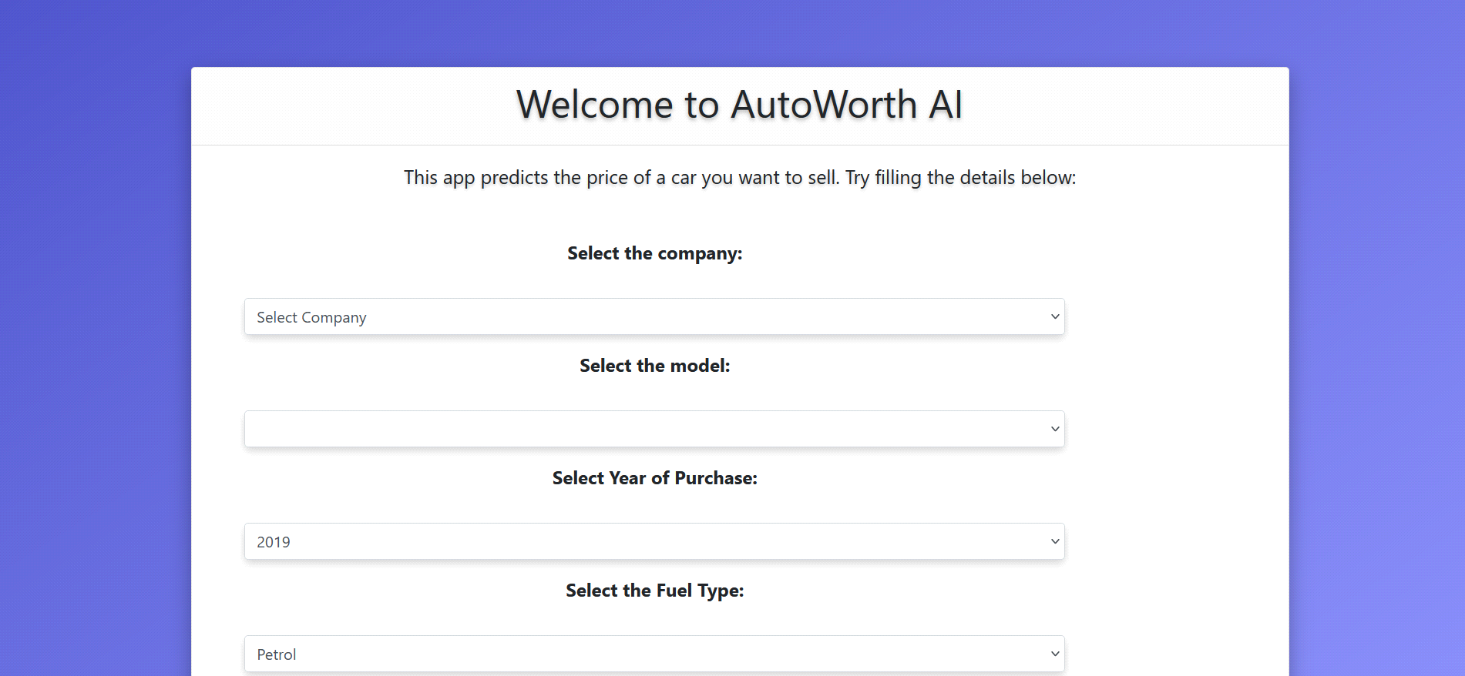

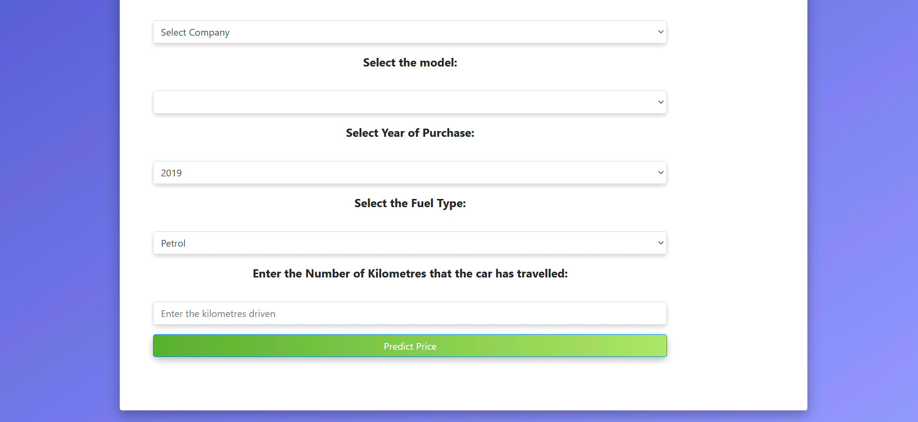

**3.2 Filling Car Details**

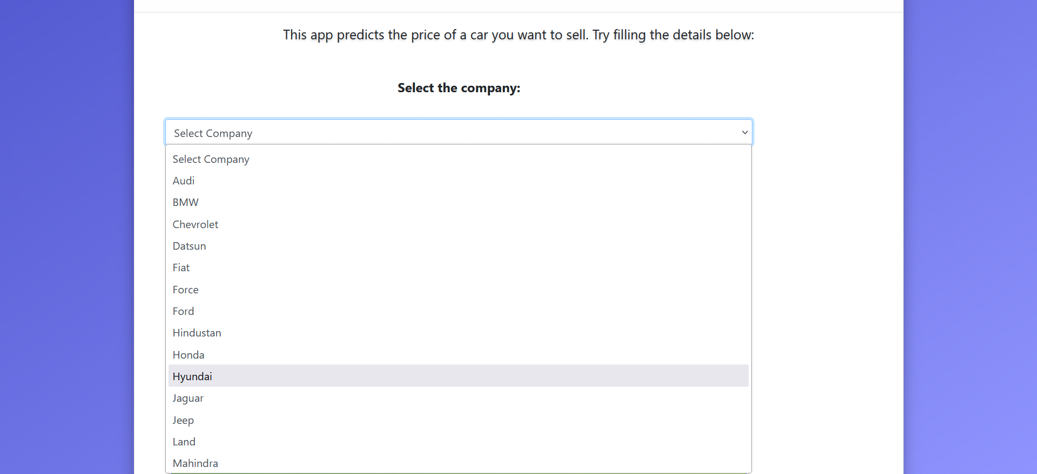

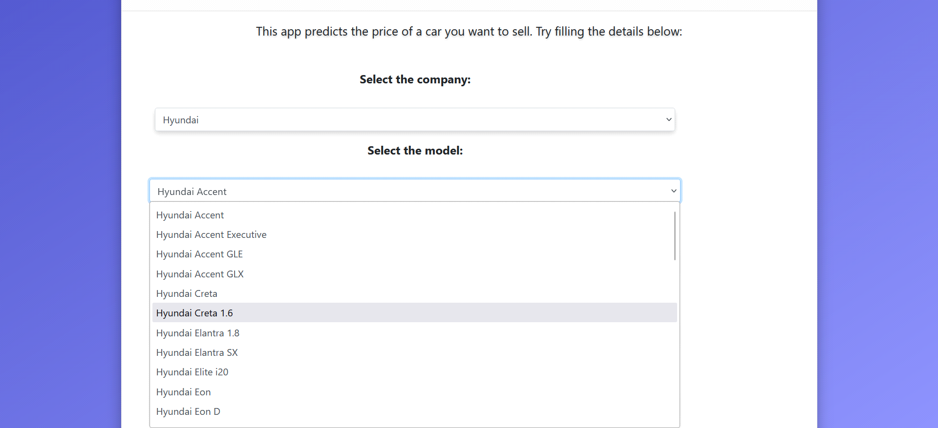

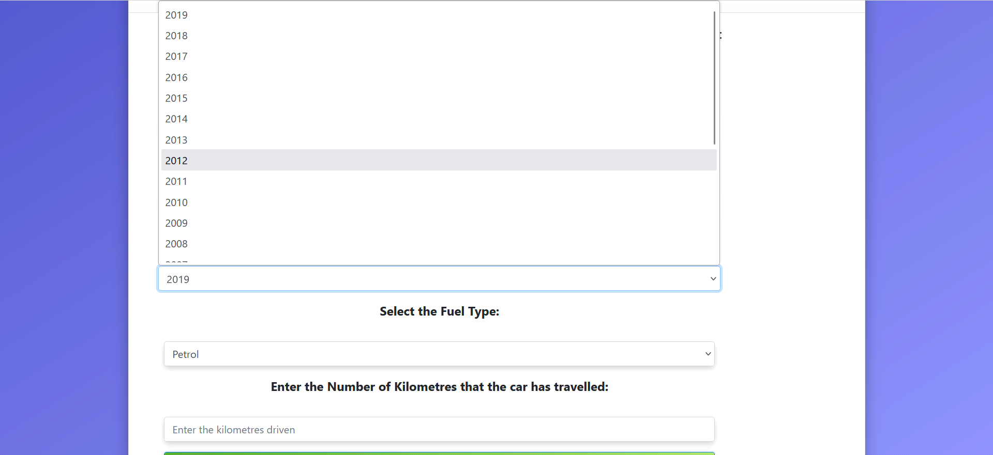

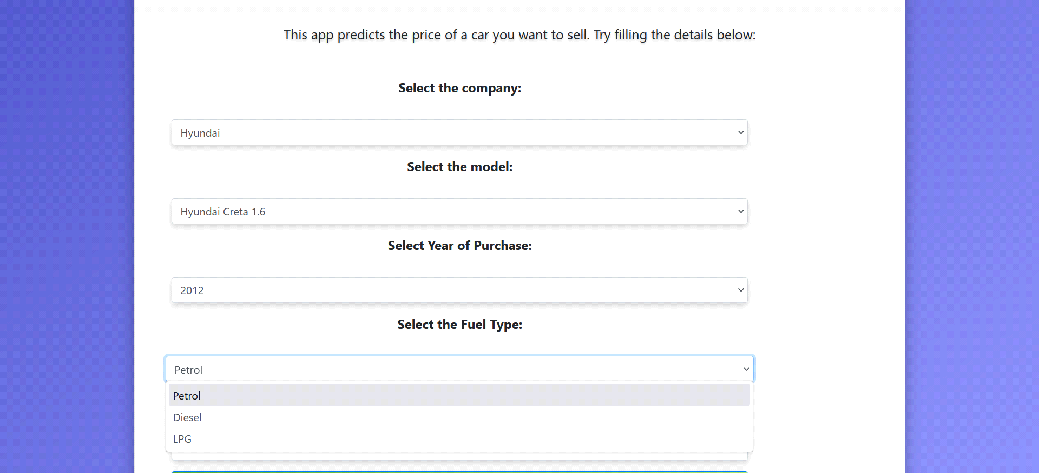

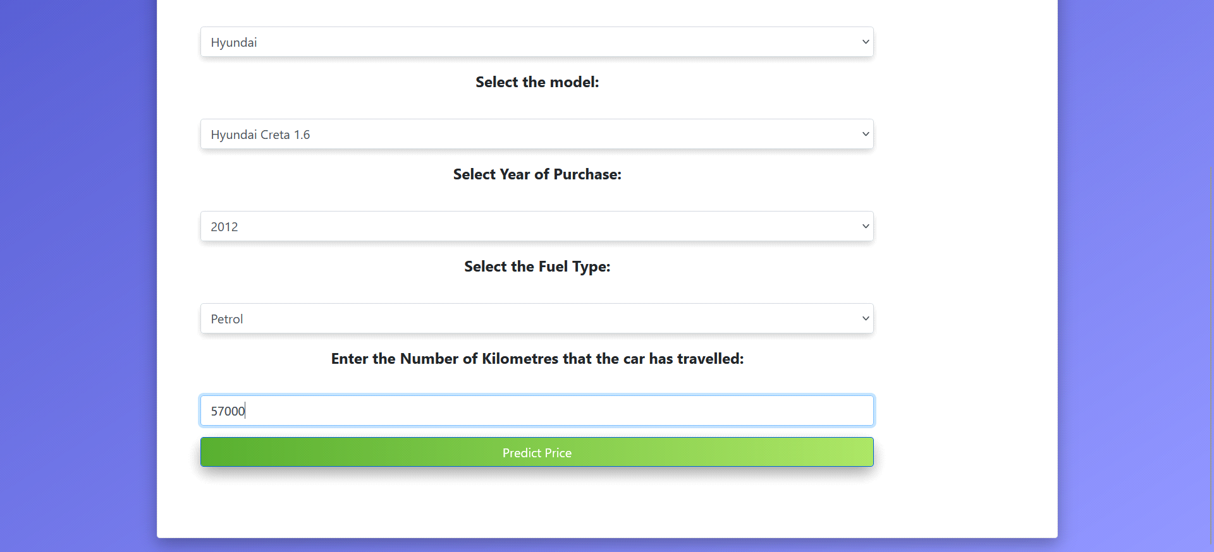

**3.3 Prediction**

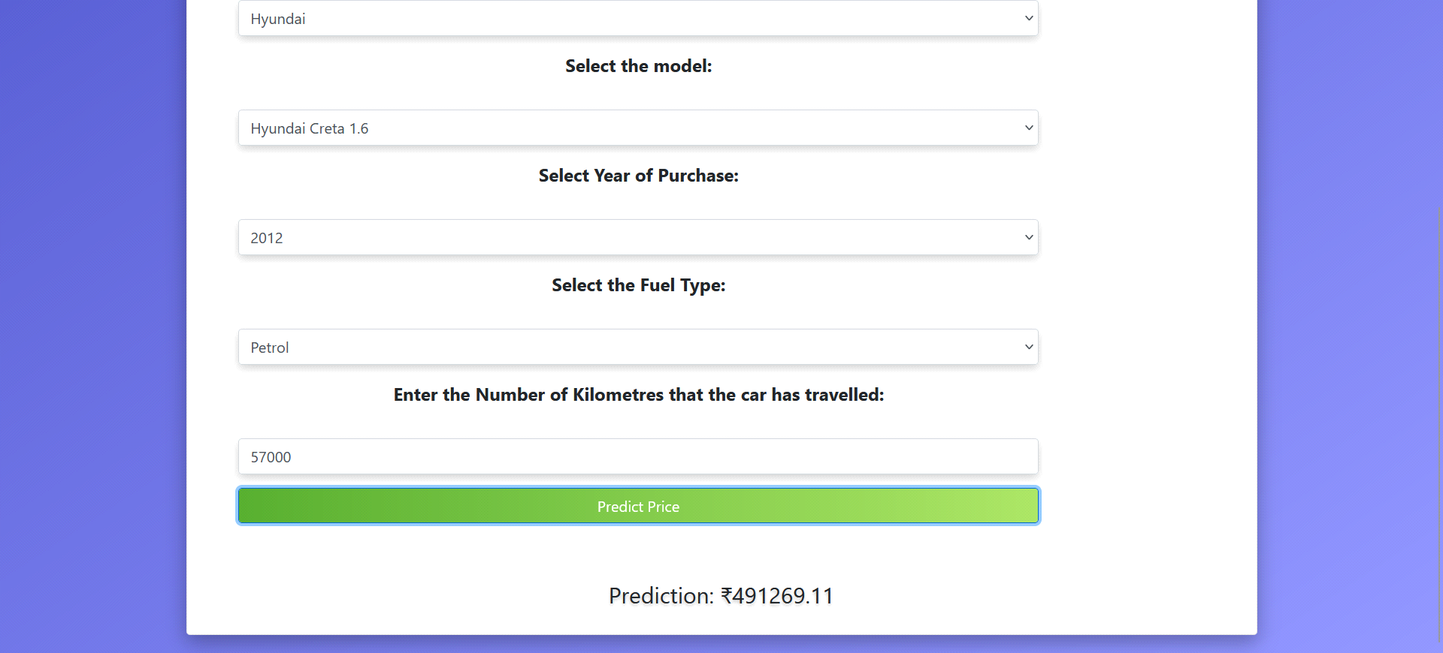

**Chapter 4**

**Applications and Scope**

**4.1 Application**

• **Car Buying Assistance:** Helps buyers determine a fair price for used and new cars, ensuring they make cost-effective purchases.

• **Car Selling Guidance:** Assists sellers in pricing their vehicles competitively in the market by providing accurate valuations based on features and market trends.

• **Dealerships and Marketplaces:** Enables car dealerships and online platforms to integrate predictive pricing tools, offering transparency and trust to customers.

• **Loan and Insurance Valuation:** Supports financial institutions and insurance providers in assessing car values for loan approvals and premium calculations.

• **Market Analysis:** Provides valuable insights for automotive analysts to understand pricing trends, demand-supply dynamics, and customer preferences.

• **Fleet Management:** Aids fleet operators in estimating the resale value of vehicles for better asset management and decision-making.

**4.2 Future Scope**

• **Enhanced Prediction Accuracy:** Implementing advanced machine learning algorithms, including deep learning, to provide more precise car price estimations by capturing intricate patterns in data.

• **Real-Time Market Integration:** Incorporating real-time market trends, regional economic factors, and live data to deliver dynamic and up-to-date pricing.

• **Electric Vehicle (EV) Support:** Expanding to include valuation for EVs and hybrids by considering factors like battery health and charging infrastructure.

• **Personalized Recommendations:** Offering tailored pricing insights and car suggestions based on individual user preferences and needs.

• **Global Scalability:** Adapting the platform for diverse international markets with localized data, currency conversions, and region-specific features.

**References**

• **Scikit-learn Documentation**: A comprehensive guide for Scikit-learn, a library used for implementing machine learning algorithms such as regression and classification. It provides detailed examples and API references for efficient model development.

**• Python Pandas Documentation**: A resource for using Pandas, a powerful library for data manipulation and analysis, essential for handling large datasets and preparing them for machine learning models.

**• Research Papers**: Studies exploring the application of machine learning in pricing models, offering theoretical insights and real-world applications that guided the project design and implementation.

**• HTML and CSS Tutorials**: Educational resources on creating responsive and user-friendly web interfaces, ensuring the project's frontend is visually appealing and functional for users.

**• Kaggle Datasets and Forums**: A platform offering diverse datasets and a community for sharing best practices in machine learning, instrumental in training models and refining project strategies.